UNITING CHURCH IN AUSTRALIA
PRESBYTERY OF ILLAWARRA
ABN: 74 041 246 188
Focused on God’s Mission – Providing Leadership – Growing Discipleship

Safe Working at Heights
Falls from ladders have resulted in a significant number of serious and fatal injuries, even when working at relatively low heights. While ladders are often considered to be the first option when working at heights, they should only be considered after safer alternatives, for example elevating work platforms (EWPs) or scaffolding, have been considered first and found to be not reasonably practicable.

Portable ladders

Extension or single ladders should only be used as a means of access to or exit from a work area or for short duration light work that can be carried out safely from the ladder.

Selecting ladders
Ladders should be selected to suit the work to be carried out. In doing this, you should consider the duration of the work, the physical surroundings of where the work is to be carried out and the prevailing weather conditions.
Depending on the specific task and how it is carried out, step platforms (see Figure 28) should provide an improved level of fall protection over traditional step or single ladders as they include a small working platform and a partial handrail.
Ladders should have a load rating of at least 120 kg and be manufactured for industrial use. Domestic or ‘homemade’ ladders should not be selected for industrial use or for use on construction sites.

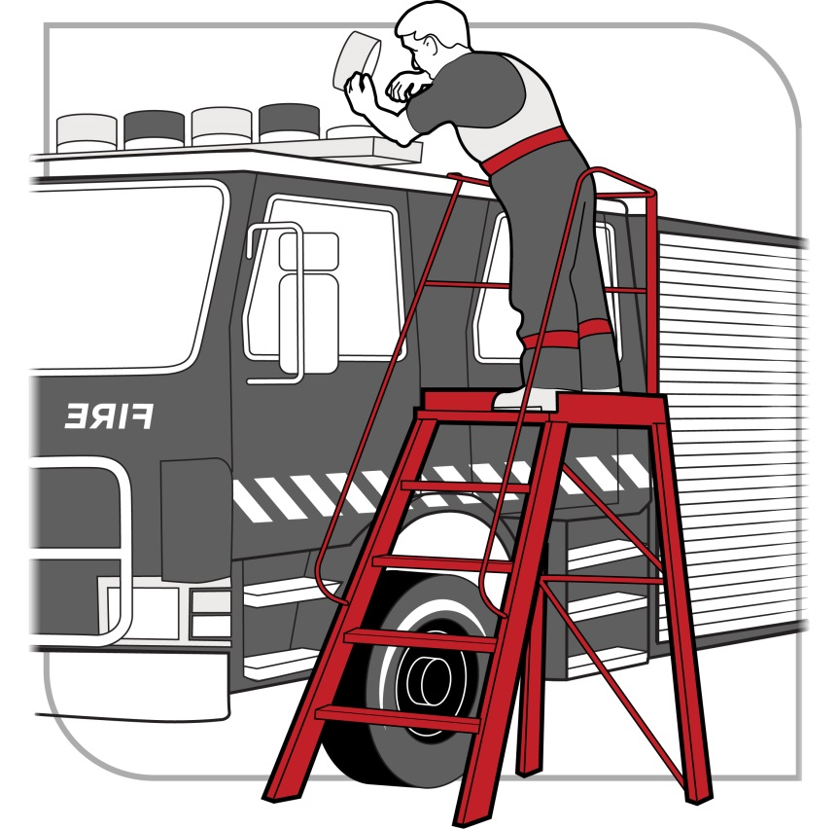
Figure 28 A step platform can provide a stable work surface

Using ladders safely

Workers must be provided with information and training on how to use ladders safely. You should only use a ladder if you have been trained in how to inspect, set up and use ladders correctly.

Positioning and setting up ladders
Before setting up a ladder, it should be inspected for visible damage or faults, for example broken rungs, stiles and footings. Faulty or damaged ladders must be removed from service.
When setting up a ladder you should check that:
- the ladder is the correct height for the work to avoid over-reaching or stretching
- locking devices on the ladder are secure, and
- the ladder is not placed so that the weight of the ladder and any person using the ladder is supported by the rungs.
Ladders used at a workplace should be set up on a solid and stable surface, and to prevent the ladder from slipping. Single and extension ladders can be prevented from slipping by:
- ensuring the ladder has non-slip feet
- placing ladders at a slope of 4:1 (the distance between the ladder base and the supporting structure should be about 1 metre for every 4 metres of working ladder height), and
- securing ladders at the top or bottom, or if necessary, at both ends (see Figure 29).
Stepladders should be set up in the fully opened position and may require a second person to ‘foot’ the ladder for added stability.
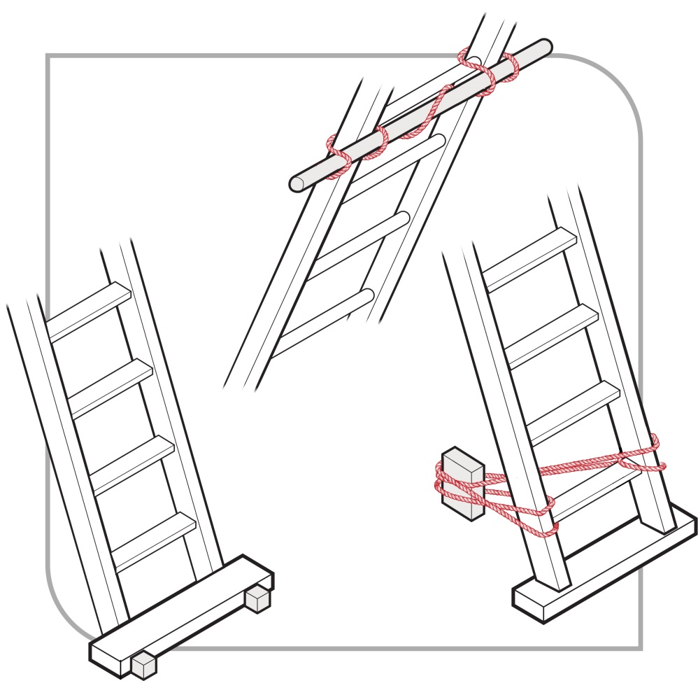
Figure 29 Examples effectively securing a ladder
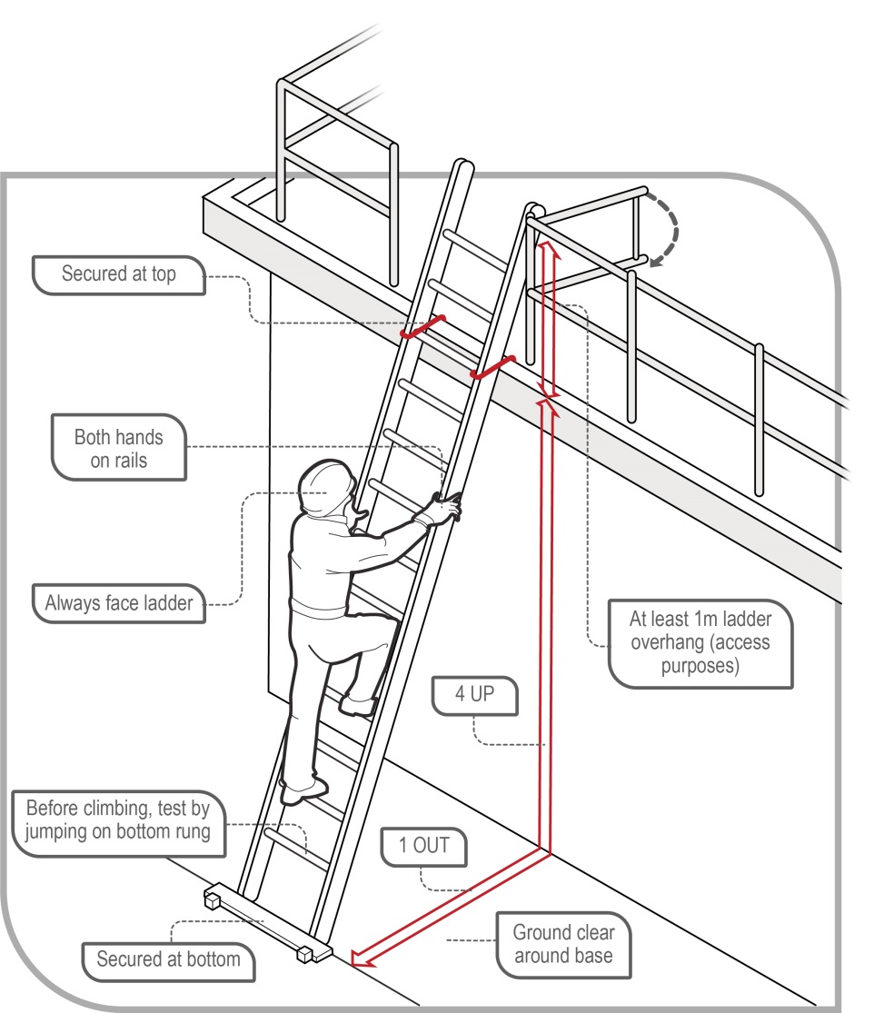
Figure 30 Example of acceptable ladder use

Safe use of ladders
When using a ladder:
- always maintain ‘three points of contact’ as follows:
- when going up or down a ladder, always have two feet and one hand, or one foot and two hands, on the ladder
- when working from a ladder, have two feet and one other point of contact with the ladder, such as a hand or thighs leaning against the ladder.
- use a tool belt or side pouch so that materials or tools are not carried in the hands while climbing the ladder
- ensure only light duty work is carried out while on the ladder, where tools can be operated safely with one hand
- make sure that no-one works underneath the ladder
- do not allow anyone else on the ladder at the same time
- do not straddle the ladder, and
- wear slip-resistant footwear.
When using ladders it is not safe to:
- use metal or metal reinforced ladders when working on live electrical installations, or
- carry out ‘hot’ work like arc welding or oxy cutting.
Except where additional fall protection equipment is used in conjunction with the ladder, it is not safe to:
- use a stepladder near the edge of an open floor, penetration or beside a railing
- over-reach—the centre of the torso should be within the ladder stiles throughout the work
- use power or hand tools requiring two hands to operate, for example concrete cutting saws and circular saws
- use tools that require a high degree of leverage force which, if released, may cause the user to over-balance or fall from the ladder, for example stillsons or pinch bars
- face away from the ladder when going up or down, or when working from it
- stand on a rung closer than 900 mm to the top of a single or extension ladder, or
- stand higher than the second tread below the top plate of a stepladder with the exception of three-rung stepladders, unless working through an overhead opening of the building or structure that provides appropriate additional support above the ladder.
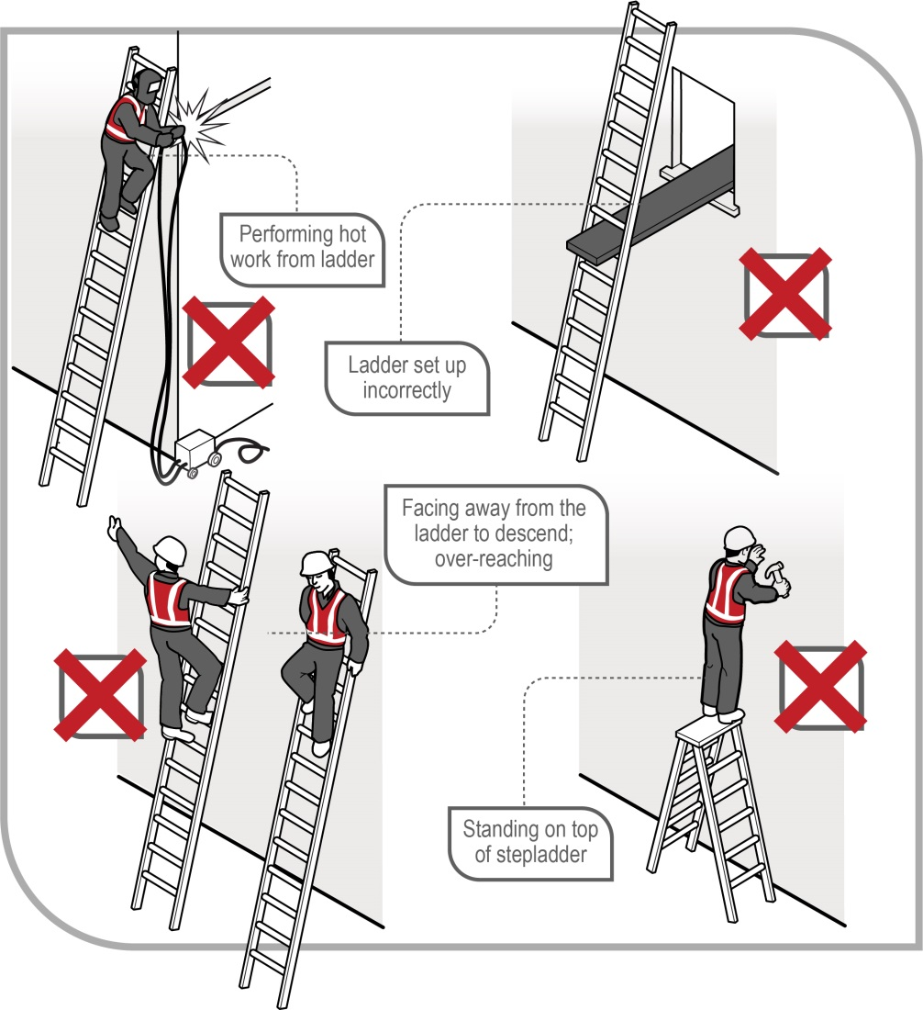
Figure 31 Examples of unsafe ladder use
Ladder use in the following situations should only be carried out with additional safety precautions in place:
- in access areas or doorways—if necessary, erect a barrier or lock the door shut
- next to powerlines, unless the worker is trained and authorised and the correct ladder for the work is being used
- in very wet or windy conditions, and
- next to traffic areas, unless the working area is barricaded.
Where single or extension ladders are used for entry and exit, you should check that:
- there is a firm, stable work platform, free from obstructions, to step onto from the ladder
- the ladder is securely fixed
- the ladder extends at least 1 metre above the stepping-off point on the working platform, and
- fall protection is provided at the stepping-off point where people access the working platform.
As an alternative to using ladders as a means of access in stairwells, you should consider having the staircase installed as soon as possible.
Further information on the selection, safe use and care of portable ladders is set out in AS/NZS 1892 (set): Portable ladders.
The ladder manufacturer’s recommendations on safe use should also be followed.

Fixed ladders
Fixed ladders should be installed in accordance with AS 1657–2018: Fixed platforms, walkways, stairways and ladders – Design, construction and installation.
Ladder cages on vertical fixed ladders, that is, over 75 degrees to the horizontal, do not stop a fall but simply funnel a fall and, in some cases, more injuries can occur from striking the protective backguards on the way down. The cages may also hinder rescues. Therefore, fixed ladders with angles exceeding 75 degrees to the horizontal should be fitted with a permanent or temporary fall arrest system using anchorage lines or rails.
The ladder’s angle of slope should not be less than 70 degrees to the horizontal and not greater than 75 degrees to the horizontal. In no case should the ladder overhang the person climbing the ladder. If the angle is more than 75 degrees, a safe system of work to prevent falls should be provided, for example a permanent fall arrest system or a full body harness with double lanyard.
A specifically designed rescue procedure should be developed for use in ladder cage situations. Training in rescue procedures should occur before using the fixed ladder.

Ladder maintenance
Ladders should be regularly inspected by a competent person in accordance with the manufacturer’s recommendations. Ladders with any of the following faults should be replaced or repaired:
- fibreglass stiles cracked, chipped or severely faded with fibres exposed
- timber stiles warped, splintered, cracked or bruised
- metal stiles twisted, bent, kinked, crushed or with cracked welds
- rungs, steps, treads or top plates that are missing, worn, damaged or loose
- tie rods missing, broken or loose
- ropes, braces or brackets that are missing, broken or worn
- timber members that are covered with opaque paint or other treatment that could disguise faults in the timber
- missing, loose, bent or worn fasteners, that is rivets, bolts and pins, and/or
- worn or damaged feet including non-slip material, pins, and/or
- worn or damaged feet including non-slip material.
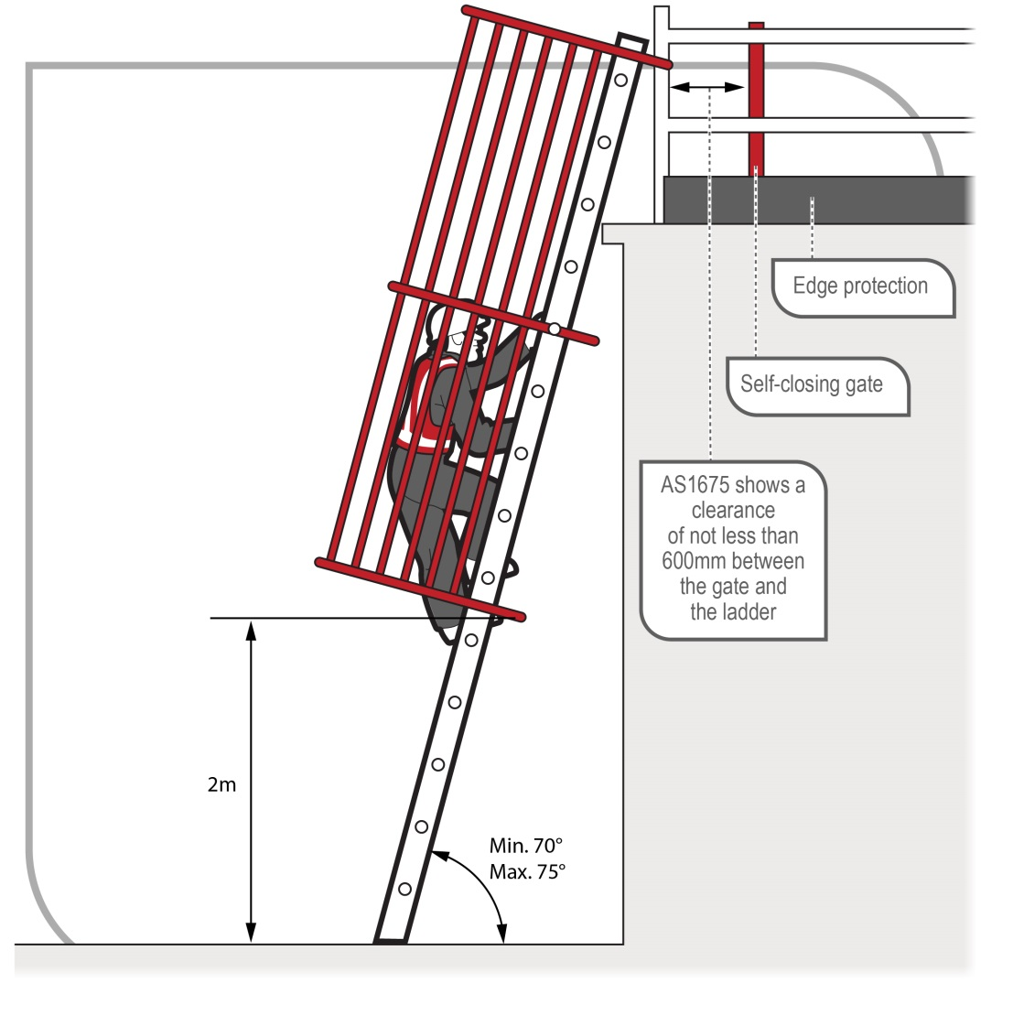

https://www.safework.nsw.gov.au/hazards-a-z/ladders
Video: Watch this video safety alert for more tips on working safely with ladders.

AS/NZS 1892 (set): Portable ladders includes AS/NZS 1892.1:1996: Portable ladders – Metal; AS 1892.2–1992: Portable ladders – Timber; AS/NZS 1892.3:1996: Portable ladders – Reinforced plastic; AS/NZS 1892.5:2000: Portable ladders – Selection, safe use and care.

