UNITING CHURCH IN AUSTRALIA
PRESBYTERY OF ILLAWARRA
ABN: 74 041 246 188
Focused on God’s Mission – Providing Leadership – Growing Discipleship

INFORMATION - CONFINED SPACES

Information in this document is a summary of the Safe Work Australia Confined Spaces Code of Practice, February 2016
Link https://www.safeworkaustralia.gov.au/system/files/documents/1705/mcop-confined-spaces-v3.pdf

Introduction

Confined spaces pose dangers because they are usually not designed to be areas where people work. Confined spaces often have poor ventilation which allows hazardous atmospheres to quickly develop, especially if the space is small. The hazards are not always obvious and may change from one entry into the confined space to the next.

The risks of working in confined spaces include:
- loss of consciousness, impairment, injury or death due to the immediate effects of airborne contaminants
- fire or explosion from the ignition of flammable contaminants
- difficulty rescuing and treating an injured or unconscious person
- asphyxiation resulting from oxygen deficiency or immersion in a free-flowing material, such as grain, sand, fertiliser, water or other liquids.

Who has health and safety duties in relation to a confined space?
- A person conducting a business or undertaking has the primary duty under the WHS Act to ensure, so far as is reasonably practicable, that workers and other persons are not exposed to health and safety risks arising from the business or undertaking.
- The WHS Regulations include specific obligations on a person conducting a business or undertaking who has management or control of a confined space.
- Officers, such as company directors, have a duty to exercise due diligence to ensure that the business or undertaking complies with the WHS Act and Regulations. This includes taking reasonable steps to ensure that the business or undertaking has and uses appropriate resources and processes to eliminate or minimise risks that arise from entry into confined spaces.
- Workers must take reasonable care for their own health and safety and that their work does not adversely affect the health and safety of other persons. Workers must comply with any reasonable instructions given relating to confined space entry permits, risk control measures and emergency procedures, and should carry out work in a confined space in accordance with any relevant information and training provided to them.
- Emergency service workers are not required to comply with some requirements for entering confined spaces when either rescuing a person or providing first aid to a person in the space (WHS Regulations 67 and 68).

How to determine whether a space is a confined space

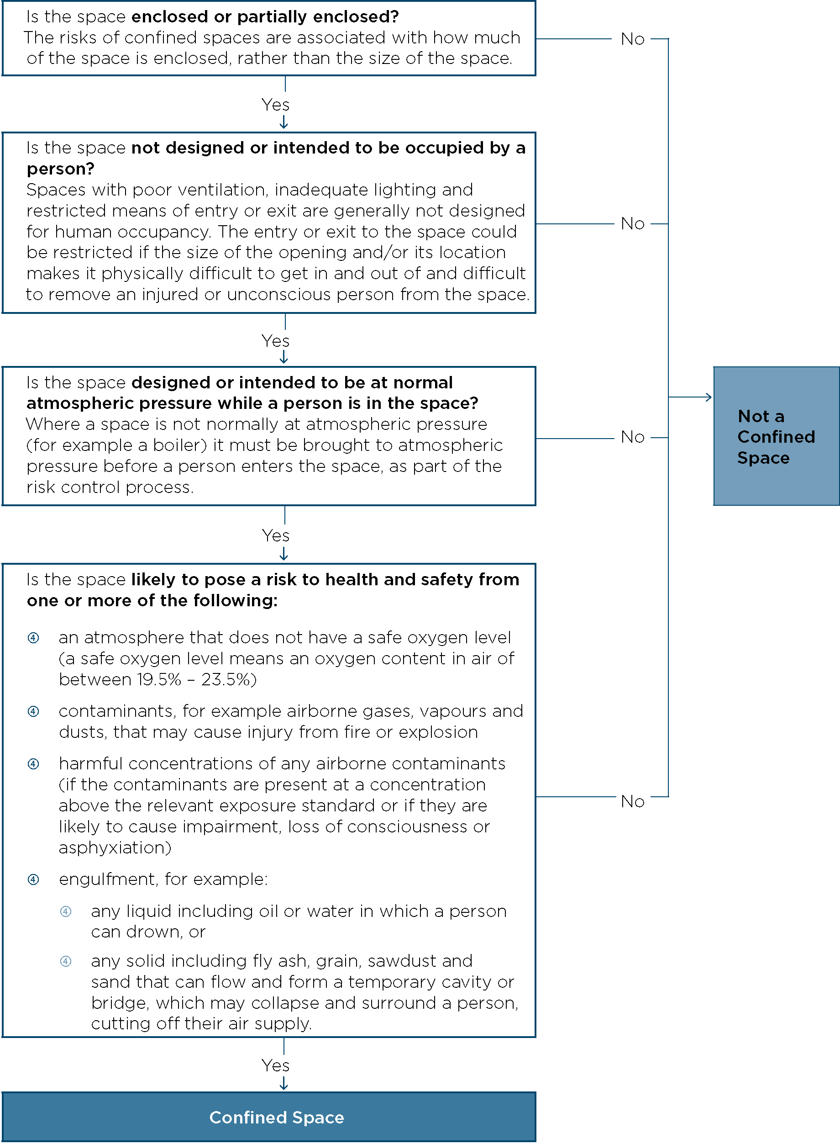

Entry permits
A confined space entry permit provides a formal check to ensure all elements of a safe system of work are in place before people are allowed to enter the confined space. It also provides a means of communication between site management, supervisors and those carrying out the work and ensures that the person conducting the business or undertaking has checked and authorised the entry to the confined space and it is safe to proceed.

Regulation 67

A competent person is one who has acquired through training, qualification or experience, the knowledge and skills to carry out this task.
Regulation 77
A person conducting a business or undertaking must not allow or direct a worker to enter a confined space to carry out work unless the person has issued a confined space entry permit for the work.
The permit must be completed in writing by a competent person and:
- specify the confined space to which the permit relates
- record the names of persons permitted to enter the confined space and the period of time that the work will be carried out
- set out risk control measures based on the risk assessment, and
- contain space for an acknowledgement that work in the confined space has been completed and all persons have left the space.
The permit must be kept until the work is completed, or if a notifiable incident occurs, for at least 2 years after the confined space work to which the permit relates is completed.
A confined space entry permit must be issued for each entry into the confined space. Each permit only applies to one confined space and allows one or more workers to enter that space. A competent person who directs and supervises the work should be nominated and authorised to issue the permit on behalf of the business or undertaking.

